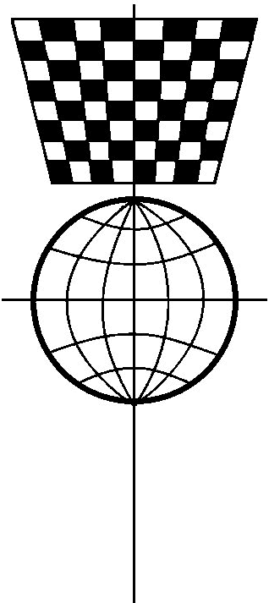
2026
Scottish Correspondence Chess Association
Membership Application/Renewal Form

This form is for annual or new members. Existing life or patron members should only return this form if they wish to inform of a change of personal details.

Section A: Your Personal Details
Please enter or amend your details as appropriate.

Full Name

Address

Postcode
Telephone (include STD code)

Mobile Telephone

Email Address
Are you happy for the SCCA to publish your email address on its website? |  |  |  |  | (yes/no)
Your Rating? |  | (SCCA) | (ICCF) | (CS OTB) | (Other)
Date of Birth (if under 21, dd/mm/yy) |  |  | Born in Scotland? |  | (yes/no)
Scots Parents? |  | (yes/no) | Resident in Scotland? |  | (years)

Please note that the SCCA holds your personal details only for the purpose of team selection, general administration and grading. They will not be revealed to anyone without your permission.

Section B: Your Membership Category
Please note that you must remain a member throughout the duration of any domestic and international events you enter.
 |  | Fee | Total
Patron Member  (Life subscription, free entry to domestic events, printed magazine free if requested for 1st year, e-magazine.) |  | £125 minimum
Life Member  (Life subscription, printed magazine free if requested for 1st year, e-magazine.) |  | £100
Annual Member  (Annual subscription, e-magazine.) |  | £10
Associate Member  (This covers non-members who may be magazine subscribers or 100 Club subscribers.) |  | £nil
Please note that to enter this season’s events and/or make a donation, you’ll need to complete the Tournament Entry Form.

Please make cheques and postal orders payable to the Scottish Correspondence Chess Association
To pay by bank transfer please refer to Scottish Correspondence Chess Association,
Sort Code 80-91-28, Account Number 00248355.
Please return your membership form and payment to:
Benjamin Major
Email: membership@scottishcca.co.uk or
Post: 39 Hillhead Rod, Kirkintilloch, Glasgow, G66 2HT
Tel: 07961 238 123
Visit https://www.scottishcca.co.uk for full SCCA news and information.

